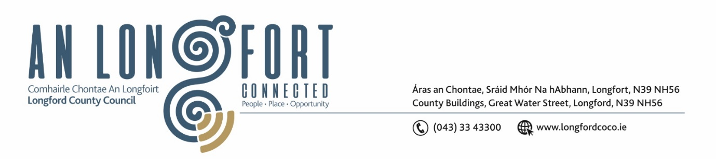

***Please note meeting will be held in the Council Chamber and via Microsoft Teams.***

5 Iúil 2023

**Chuig: Gach Ball don Chomhairle**

A Chomhairleoir,

Iarrtar ort bheith i láthair ag Cruinniú Míosuil Chomhairle Chontae Longfoirt a tionólfar i Seomra na Comhairle, Aras an Chontae, Longford agus via MS Teams are an **Chéadaoin 12ú Iúil 2023 ag 4pm** chun gnó a dhéanamh d’réir an Chláir thíos.

You are requested to attend the Monthly Meeting of Longford County Council to be held in the **Council Chamber and via Microsoft Teams** on **Wednesday 12 July 2023 at 4pm** to transact business, as set out on the Agenda hereunder.

Mise le meas,

**__________________**

***Claire McNabola***

***Meetings Administrator.***

**C L Á R**

Prayer before meeting.

1. Confirmation of Minutes:
2. Monthly meeting of Longford County Council held on 14 June 2023 - enclosed
3. Matters Arising.

**3.** Declaration of Interest by Members.

1. To note Management Report – To Follow

**5.** To note adopted Minutes of Corporate Policy Group Meeting held on the

1. May 2023 – enclosed.
2. **Finance and Information Technology**
3. Consideration of disposal of Property at Currabawn, Ballymahon, Co Longford, in accordance with the terms of Section 183 of the Local Government Act 2001 issued on the 31 May 2023 – as circulated.
4. Statutory Audit Report to the members of Longford County Council for the year ended 31 December 2022 - Local Government Audit Service

**8. Housing, Planning, Regeneration & Capital Projects**

1. To note Planning Applications received since last meeting of the Council.
2. Presentation on County Development Plan
3. Consideration of disposal of Property at Aughaloughlan, Lanesborough, Co Longford, in accordance with the terms of Section 183 of the Local Government Act 2001 issued on the 1 June 2023 – as circulated.

**9. Community, Library and Cultural Services, Corporate and Human Resources**

**(a)** Approval to the appointment of Ms Rosalind Greene, nominee of County Longford Public Participation Network, to replace Ms. Grace Kearney as a member of Longford Local Community Development Committee (LCDC).

**9. Correspondence**

1. Correspondence received on 23 June 2023 from Minister for Health re. home-help support.

**10. Votes of Sympathy**